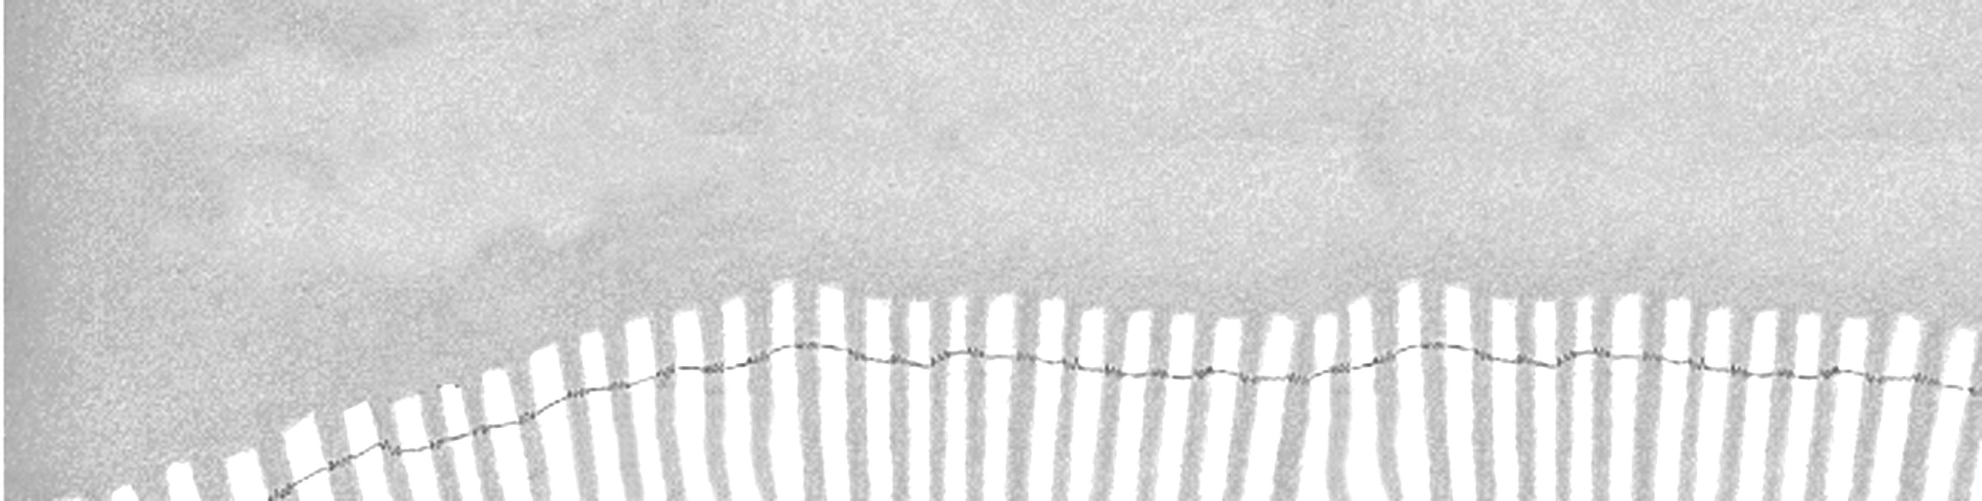

THE STONE HAT
Book Notes
Lesson Plan
Books for Young Learners Teacher Resource
Author Douglas Hood 2nd grade Fictionalized nonfiction
Illustrator Tom Simonton 16 pages 849 words
Topic Chinese history, archaeology
Levels Fountas/Pinnell - M Reading Recovery - N/A
Shared - Fluent 3 Guided - Fluent 4 Independent - Fluent 4
S=Shared G=Guided I=Independent
EM EARLY FLUENT
S GI GI
1 2 3 4 1 2 3 4 4

SYNOPSIS  WHAT  THE BOOK  OFFERS  POSSIBLE SKILLS  EMPHASIS | A story of how a young boy helped discover the ancient, underground army  of the first emperor of China.  ■ Historical narrative fiction with accurate details but fictional characters  ■ Third person, present tense changes to third person, past tense  ■ Detailed descriptive writing  ■ Dialogue used to develop story  ■ A story within a story  ■ Simple, compound, and complex sentence structures, with a variety of  sentence lengths  ■ Commas to set off explanatory phrases  ■ Quotation marks  ■ Dashes for compound words and to set off phrases  ■ Vocabulary: Root words to decode new words  ■ Phonics: Letter-sound knowledge and chunking to read multi-syllable words  fluently  ■ Fluency: Opportunities to practice expressive reading of dialogue; to read  repetitive words; to create rhythm and tension when reading a combination  of short and long sentences  ■ Comprehension: Genre of historical fiction with opportunities to predict,  infer, clarify meaning, summarize, and separate details from fictional details  ■ Use of table of contents to predict what the book will be about  ■ Separating factual details from fictional details  ■ Tracking the passage of time in each of the chapters  ■ Understanding specialized vocabulary in context  ■ Setting a purpose for reading  ■ Identifying key information  ■ Asking “I wonder” questions
Book Notes
Books for Young Learners Teacher Resource
Lesson Plan

INTRODUCING  THE BOOK  FOCUS OF INSTRUCTION  FOLLOWING THE  READING | Look at the cover and title page and think of what you know about text features  that will help you anticipate what this story is going to be about.  Teacher charts the students’ predictions.  Teacher checks that students use the pictures, the title, the chapter titles, subheadings, and the definition of terra-cotta in the special note on the inside front cover.  Draw students’ attention to the hat that the main character is holding on the front  cover and the hat on the warrior on the title page.  Set a purpose for reading: Let’s read to see which predictions are confirmed and which predictions need to be modified.  Have students read Chapters 1 and 2 silently.  Stop at the end of Chapter 2 and discuss the story so far.  Possible questions:  Which predictions have been confirmed? What do you think will happen next?  What makes you think that? How did Li Ching’s father react to his discovery?  How did his teacher react? Why do you think they reacted so differently?  Reread pg. 9. Now read the title of Chapter 3.  How does the author set the reader up for what is going to happen next?  Have students read Chapters 3, 4, and 5 silently.  Possible questions to discuss at the end of Chapter 5:  Which predictions have been confirmed? What important information did we  find out about who made and buried the terra-cotta army?  How do you think Li Ching and his teacher felt when seven thousand  warriors were found—each one different from the next? (Clues on pg. 13)  Do you think it was right for Qin Shi Huang to force a million men to make him  the terra-cotta warriors? Give reasons for your answer.  Reread pg. 16. Tell in your own words what you think the author is saying here.  Is there a lesson (or theme) to be learned from this story?  ORAL DISCUSSION  ■ Read the Author’s Note on the back cover and explain to students that this story  is historical fiction. The characters and dialogue are fiction, but the information  about the finding of the terra-cotta warriors is accurate nonfiction.  ■ Skim back through the story and discuss the fiction details vs. the nonfiction ones.  ■ Brainstorm “I wonder” questions generated by the text.  WRITING POSSIBILITIES  ■ Students research their “I wonder” questions and publish the answers.  For example: Were other artifacts unearthed besides war wagons, chariots, horses,  and warriors? How long did it take archaeologists to unearth and reassemble the  terra-cotta warriors? Where are the warriors now?

